Presentation Caption
Login Screen: The application entry point where users securely access the Excelerate Learning Hub. The screen incorporates consistent Excelerate branding and provides an intuitive authentication experience before navigating to the Home Dashboard.
Figure 1. Login Screen Code Snippet
figure1_login_screen.png

Scaffold(
backgroundColor: const Color(0xFFF8F9FD),
body: SingleChildScrollView(
child: Padding(
padding: const EdgeInsets.all(24),
child: Column(
crossAxisAlignment:
CrossAxisAlignment.start,
children: [
const SizedBox(height: 60),
// Excelerate Logo
Row(
children: [
Column(
children: [
Container(
width: 24,
height: 3,
color: const Color(0xFFFF6A3D),
),
const SizedBox(height: 3),
Container(
width: 34,
height: 3,
color: const Color(0xFFFF6A3D),
),
const SizedBox(height: 3),
Container(
width: 44,
height: 3,
color: const Color(0xFFFF6A3D),
),
],
),
const SizedBox(width: 4),
const Text(
"Excelerate",
style: TextStyle(
fontSize: 32,
fontWeight: FontWeight.bold,
color: Color(0xFFE91E63),
),
),
],
),
const SizedBox(height: 20),
Container(
width: double.infinity,
padding: const EdgeInsets.all(16),
decoration: BoxDecoration(
gradient: const LinearGradient(
colors: [
Color(0xFFFF6A3D),
Color(0xFFE91E63),
],
),
borderRadius:
BorderRadius.circular(16),
),
child: const Text(
"Excelerate Learning Hub",
style: TextStyle(
color: Colors.white,
fontSize: 20,
fontWeight: FontWeight.bold,
),
),
),
const SizedBox(height: 50),
const Center(
child: Icon(
Icons.account_circle,
size: 90,
color: Color(0xFFE91E63),
),
),
const SizedBox(height: 15),
const Center(
child: Text(
"Welcome Back",
style: TextStyle(
fontSize: 28,
fontWeight: FontWeight.bold,
color: Color(0xFF1F2937),
),
),
),
const SizedBox(height: 8),
const Center(
child: Text(
"Sign in to continue",
style: TextStyle(
fontSize: 16,
color: Colors.grey,
),
),
),
const SizedBox(height: 40),
TextField(
decoration: InputDecoration(
labelText: "Email Address",
prefixIcon:
const Icon(Icons.email),
border: OutlineInputBorder(
borderRadius:
BorderRadius.circular(
12),
),
),
),
const SizedBox(height: 20),
TextField(
obscureText: true,
decoration: InputDecoration(
labelText: "Password",
prefixIcon:
const Icon(Icons.lock),
border: OutlineInputBorder(
borderRadius:
BorderRadius.circular(
12),
),
),
),
const SizedBox(height: 30),
SizedBox(
width: double.infinity,
child: ElevatedButton(
onPressed: () {},
style: ElevatedButton.styleFrom(
backgroundColor:
const Color(0xFFE91E63),
padding:
const EdgeInsets.symmetric(
vertical: 16,
),
shape:
RoundedRectangleBorder(
borderRadius:
BorderRadius.circular(
12),
),
),
child: const Text(
"LOGIN",
style: TextStyle(
color: Colors.white,
fontWeight:
FontWeight.bold,
),
),
),
),
const SizedBox(height: 20),
const Center(
child: Text(
"Team 4 • Excelerate Flutter Internship",
style: TextStyle(
color: Colors.grey,
),
),
),
],
),
),
),
)

Figure 2 – Home dashboard Code snippet figure2_home_dashboard.png
Scaffold(
backgroundColor: const Color(0xFFF8F9FD),
body: SingleChildScrollView(
child: Padding(
padding: const EdgeInsets.all(20),
child: Column(
crossAxisAlignment: CrossAxisAlignment.start,
children: [
const SizedBox(height: 40),
Row(
children: [
Column(
children: [
Container(
width: 24,
height: 3,
color: const Color(0xFFFF6A3D),
),
const SizedBox(height: 3),
Container(
width: 34,
height: 3,
color: const Color(0xFFFF6A3D),
),
const SizedBox(height: 3),
Container(
width: 44,
height: 3,
color: const Color(0xFFFF6A3D),
),
],
),
const SizedBox(width: 4),
const Text(
"Excelerate",
style: TextStyle(
fontSize: 32,
fontWeight: FontWeight.bold,
color: Color(0xFFE91E63),
),
),
],
),
const SizedBox(height: 20),
Container(
width: double.infinity,
padding: const EdgeInsets.all(16),
decoration: BoxDecoration(
gradient: const LinearGradient(
colors: [
Color(0xFFFF6A3D),
Color(0xFFE91E63),
],
),
borderRadius: BorderRadius.circular(16),
),
child: const Text(
"Impact Overview",
style: TextStyle(
color: Colors.white,
fontSize: 22,
fontWeight: FontWeight.bold,
),
),
),
const SizedBox(height: 20),
Card(
child: ListTile(
leading: Icon(Icons.work),
title: Text("360+ Opportunities"),
subtitle: Text("\$14,212,410+ Scholarships"),
),
),
Card(
child: ListTile(
leading: Icon(Icons.people),
title: Text("278,500+ Lives Impacted"),
subtitle: Text("Global Community"),
),
),
],
),
),
),
)

Figure 3 – Dynamic Program Listing Screen Code snippet
figure3_program_listing.png

Scaffold(
backgroundColor: const Color(0xFFF8F9FD),
body: SingleChildScrollView(
child: Padding(
padding: const EdgeInsets.all(20),
child: Column(
crossAxisAlignment:
CrossAxisAlignment.start,
children: [
const SizedBox(height: 40),
// Excelerate Logo
Row(
children: [
Column(
children: [
Container(
width: 24,
height: 3,
color: const Color(0xFFFF6A3D),
),
const SizedBox(height: 3),
Container(
width: 34,
height: 3,
color: const Color(0xFFFF6A3D),
),
const SizedBox(height: 3),
Container(
width: 44,
height: 3,
color: const Color(0xFFFF6A3D),
),
],
),
const SizedBox(width: 4),
const Text(
"Excelerate",
style: TextStyle(
fontSize: 32,
fontWeight: FontWeight.bold,
color: Color(0xFFE91E63),
),
),
],
),
const SizedBox(height: 20),
// Header Banner
Container(
width: double.infinity,
padding: const EdgeInsets.all(16),
decoration: BoxDecoration(
gradient: const LinearGradient(
colors: [
Color(0xFFFF6A3D),
Color(0xFFE91E63),
],
),
borderRadius:
BorderRadius.circular(16),
),
child: const Text(
"Available Opportunities",
style: TextStyle(
color: Colors.white,
fontSize: 20,
fontWeight: FontWeight.bold,
),
),
),
const SizedBox(height: 25),
Card(
child: ListTile(
leading: const Icon(
Icons.work,
color: Color(0xFFE91E63),
),
title: const Text(
"Digital Strategy Associate Internship",
),
subtitle: const Text(
"\$1,000 Scholarship • 6 Weeks",
),
trailing: const Icon(
Icons.arrow_forward_ios,
),
),
),
Card(
child: ListTile(
leading: const Icon(
Icons.school,
color: Color(0xFFE91E63),
),
title: const Text(
"Global Learning Innovation Associate",
),
subtitle: const Text(
"\$1,000 Scholarship • 8 Weeks",
),
trailing: const Icon(
Icons.arrow_forward_ios,
),
),
),
Card(
child: ListTile(
leading: const Icon(
Icons.analytics,
color: Color(0xFFE91E63),
),
title: const Text(
"Data Visualization Masterclass",
),
subtitle: const Text(
"\$500 Scholarship • 4 Weeks",
),
trailing: const Icon(
Icons.arrow_forward_ios,
),
),
),
],
),
),
),
)

Figure 4 – Program Details Screen Figure4_program_details.png

Scaffold(
backgroundColor: const Color(0xFFF8F9FD),
body: SingleChildScrollView(
child: Padding(
padding: const EdgeInsets.all(20),
child: Column(
crossAxisAlignment:
CrossAxisAlignment.start,
children: [
const SizedBox(height: 40),
// Excelerate Logo
Row(
children: [
Column(
children: [
Container(
width: 24,
height: 3,
color: const Color(0xFFFF6A3D),
),
const SizedBox(height: 3),
Container(
width: 34,
height: 3,
color: const Color(0xFFFF6A3D),
),
const SizedBox(height: 3),
Container(
width: 44,
height: 3,
color: const Color(0xFFFF6A3D),
),
],
),
const SizedBox(width: 4),
const Text(
"Excelerate",
style: TextStyle(
fontSize: 32,
fontWeight: FontWeight.bold,
color: Color(0xFFE91E63),
),
),
],
),
const SizedBox(height: 20),
Container(
width: double.infinity,
padding: const EdgeInsets.all(16),
decoration: BoxDecoration(
gradient: const LinearGradient(
colors: [
Color(0xFFFF6A3D),
Color(0xFFE91E63),
],
),
borderRadius:
BorderRadius.circular(16),
),
child: const Text(
"Program Details",
style: TextStyle(
color: Colors.white,
fontSize: 20,
fontWeight: FontWeight.bold,
),
),
),
const SizedBox(height: 25),
const Text(
"Digital Strategy Associate Internship",
style: TextStyle(
fontSize: 24,
fontWeight: FontWeight.bold,
),
),
const SizedBox(height: 15),
const Text(
"Develop practical digital strategy skills through real-world projects and collaborative learning experiences.",
style: TextStyle(
fontSize: 16,
),
),
const SizedBox(height: 20),
const Text(
"Duration: 6 Weeks",
style: TextStyle(fontSize: 16),
),
const SizedBox(height: 10),
const Text(
"Scholarship: \$1,000",
style: TextStyle(
fontSize: 16,
fontWeight: FontWeight.bold,
color: Color(0xFFE91E63),
),
),
const SizedBox(height: 25),
const Text(
"Key Skills",
style: TextStyle(
fontSize: 18,
fontWeight: FontWeight.bold,
),
),
const SizedBox(height: 10),
Wrap(
spacing: 10,
runSpacing: 10,
children: const [
Chip(label: Text("Research")),
Chip(label: Text("Strategy")),
Chip(label: Text("Communication")),
Chip(label: Text("Teamwork")),
],
),
],
),
),
),
)

Figure 5: Feedback Form Screen
Figure5_feedback_form.png

Scaffold(
backgroundColor: const Color(0xFFF8F9FD),
body: SingleChildScrollView(
child: Padding(
padding: const EdgeInsets.all(20),
child: Column(
crossAxisAlignment:
CrossAxisAlignment.start,
children: [
const SizedBox(height: 40),
// Excelerate Logo
Row(
children: [
Column(
children: [
Container(
width: 24,
height: 3,
color: const Color(0xFFFF6A3D),
),
const SizedBox(height: 3),
Container(
width: 34,
height: 3,
color: const Color(0xFFFF6A3D),
),
const SizedBox(height: 3),
Container(
width: 44,
height: 3,
color: const Color(0xFFFF6A3D),
),
],
),
const SizedBox(width: 4),
const Text(
"Excelerate",
style: TextStyle(
fontSize: 32,
fontWeight: FontWeight.bold,
color: Color(0xFFE91E63),
),
),
],
),
const SizedBox(height: 20),
Container(
width: double.infinity,
padding: const EdgeInsets.all(16),
decoration: BoxDecoration(
gradient: const LinearGradient(
colors: [
Color(0xFFFF6A3D),
Color(0xFFE91E63),
],
),
borderRadius:
BorderRadius.circular(16),
),
child: const Text(
"Feedback Form",
style: TextStyle(
color: Colors.white,
fontSize: 20,
fontWeight: FontWeight.bold,
),
),
),
const SizedBox(height: 25),
TextField(
decoration: InputDecoration(
labelText: "Full Name",
prefixIcon:
const Icon(Icons.person),
border: OutlineInputBorder(
borderRadius:
BorderRadius.circular(12),
),
),
),
const SizedBox(height: 20),
TextField(
decoration: InputDecoration(
labelText: "Email Address",
prefixIcon:
const Icon(Icons.email),
border: OutlineInputBorder(
borderRadius:
BorderRadius.circular(12),
),
),
),
const SizedBox(height: 20),
TextField(
maxLines: 5,
decoration: InputDecoration(
labelText: "Feedback",
alignLabelWithHint: true,
prefixIcon:
const Icon(Icons.feedback),
border: OutlineInputBorder(
borderRadius:
BorderRadius.circular(12),
),
),
),
const SizedBox(height: 25),
SizedBox(
width: double.infinity,
child: ElevatedButton(
onPressed: () {},
style: ElevatedButton.styleFrom(
backgroundColor:
const Color(0xFFE91E63),
padding:
const EdgeInsets.symmetric(
vertical: 16,
),
shape:
RoundedRectangleBorder(
borderRadius:
BorderRadius.circular(
12),
),
),
child: const Text(
"Submit Feedback",
style: TextStyle(
color: Colors.white,
fontWeight:
FontWeight.bold,
),
),
),
),
],
),
),
),
)

- figure1_login_screen.png (Screenshot)

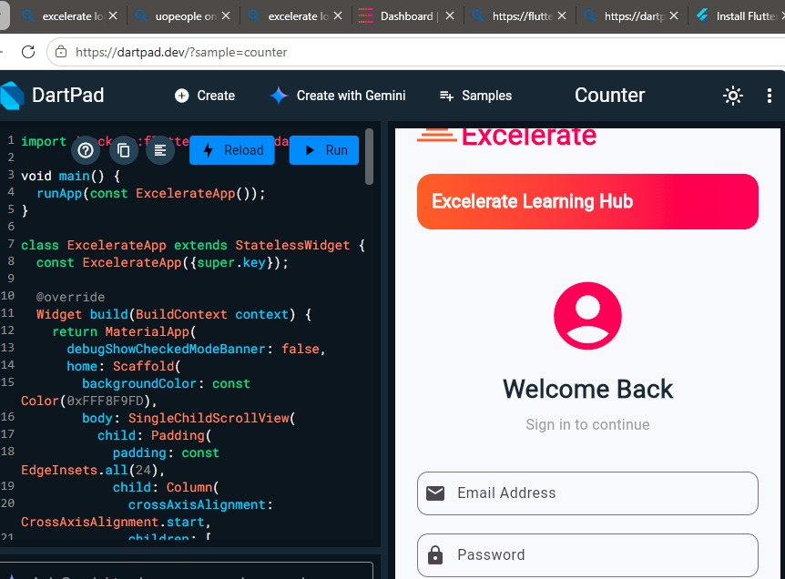

figure1_login_screen.png (Screenshot) continuation
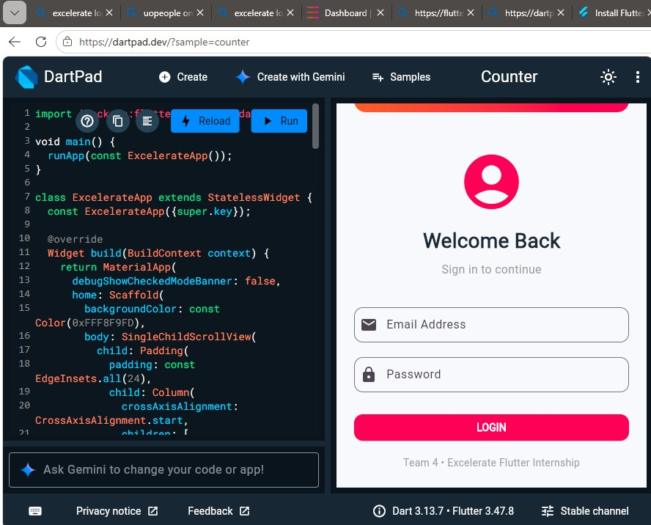

- figure2_home_dashboard.png (Screenshot)

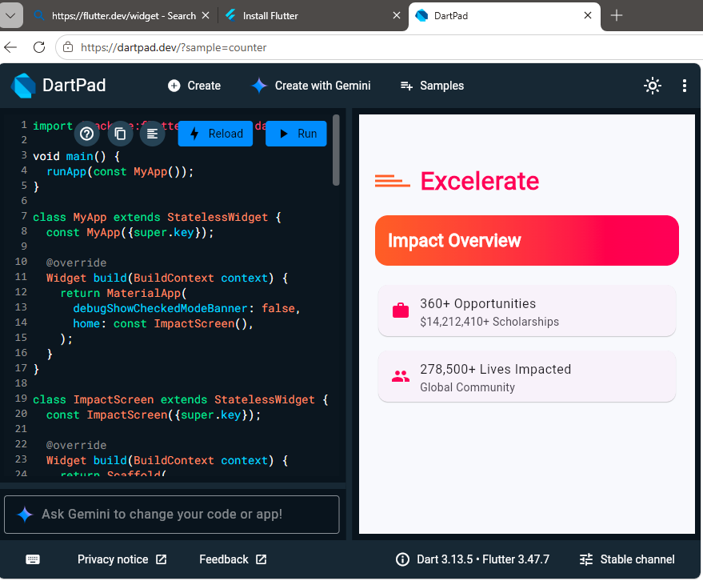

- figure3_program_listing.png (screenshot)

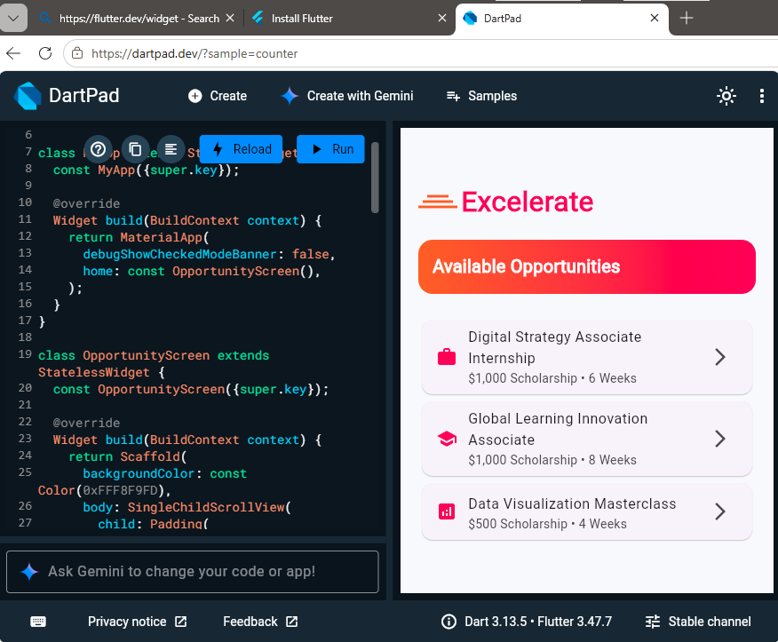

- Figure4_program_details.png (screenshot)

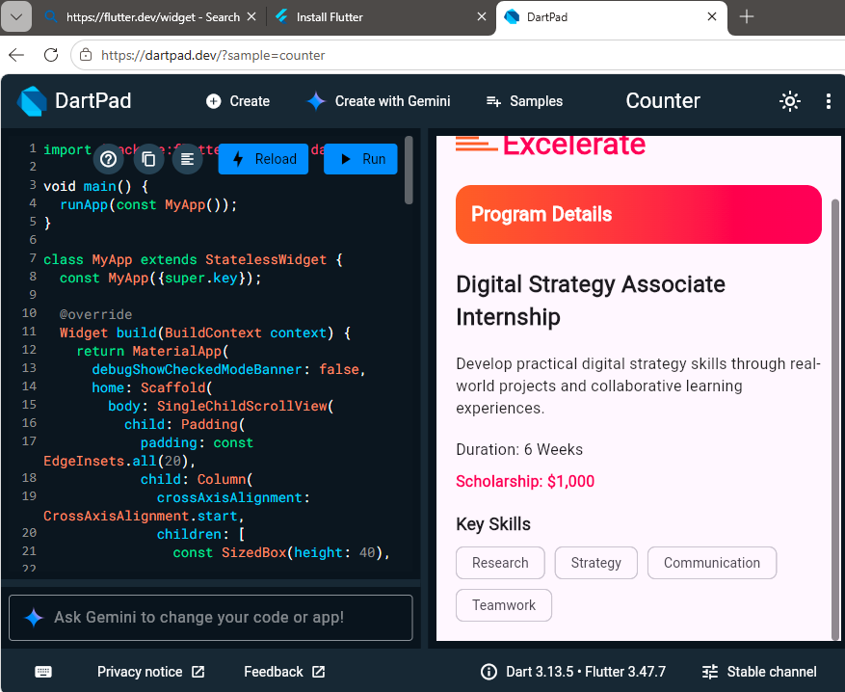

- figure5_feedback_form.png (Screenshot)



